**Lab 6**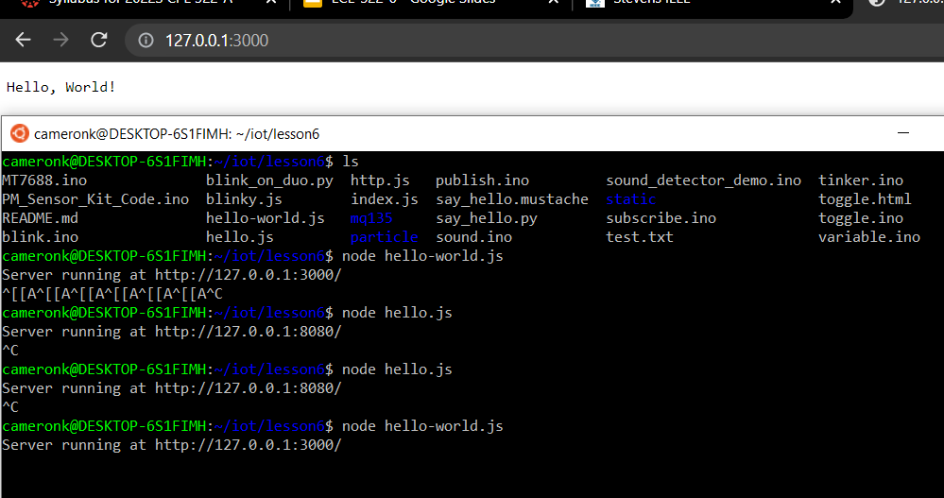

**Node.js command hello-world.js**

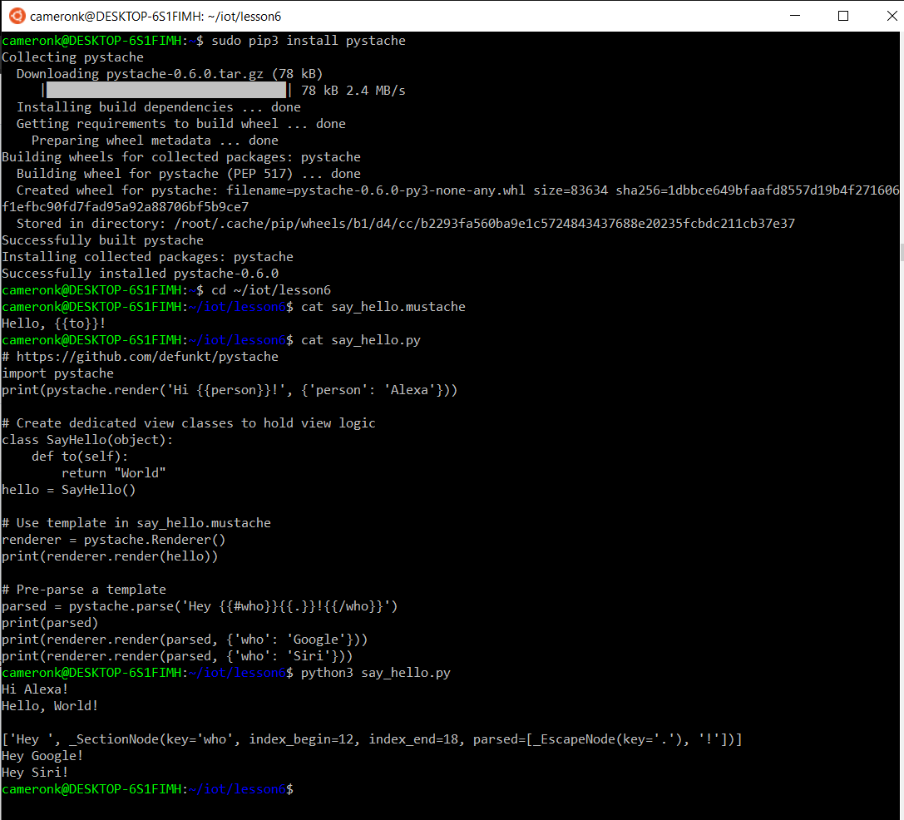

**Pystache installation and commands**